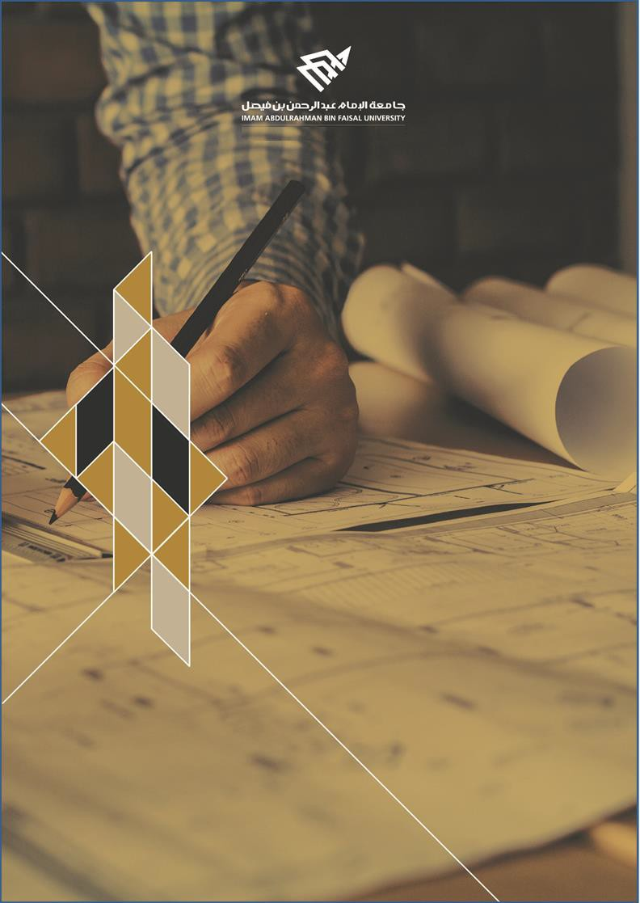

College of Computer Science and Information Technology
تامولعملا ةينقتو بساحلا مولع ةيلك

DEPARTMENT OF COMPUTER ENGINEERING

ARTI 406 – Image Processing

STUDENT PROCEDURAL MANUAL Lab 5

2025 - 2026

College | Department | Course
College of Computer Science and Information Technology | Department of  Computer Engineering | ARTI404 – Image  Processing

Practical Session Plan

Session Topic/Title | Session No. | Session Duration  (Minutes)
Spatial Filtering – Smoothing and Sharpening | 5 | 100

1- Session Outcomes

Outcome#2: Write a program that implements fundamental image processing algorithms.

2- Tool(s)/Software .
• Python 3
• Anaconda
• IDE for Python: Jupyter, Spyder.
• Libraries: OpenCV, NumPy, Pillow, Skimage, Matplotlib.

3- Procedural steps (Tasks)

Task#1: Unsharp Masking
# Read the image
image = cv2.imread('images/Parrot.png')
image = cv2.cvtColor(image, cv2.COLOR_BGR2RGB) # Convert from BGR to RGB

# Gaussian sigma
sigma=2

#parameter
amount=1.5

# Convert image to float32 for processing
image_float = image.astype(np.float32) / 255.0

# Apply Gaussian blur
blurred = cv2.GaussianBlur(image_float, (0, 0), sigmaX=sigma, sigmaY=sigma)

# Perform Unsharp Masking
sharpened = np.clip(image_float + amount * (image_float - blurred), 0, 1)
# Plot original, blurred, and sharpened images
fig, ax = plt.subplots(1, 3, figsize=(15, 5))

ax[0].imshow(image)
ax[0].set_title("Original Image")
ax[0].axis("off")

ax[1].imshow(blurred)
ax[1].set_title("Blurred Image")
ax[1].axis("off")

ax[2].imshow(sharpened)
ax[2].set_title("Sharpened (Unsharp Masking)")
ax[2].axis("off")

plt.show()

4- Assessment

The student will be asked to accomplish the following tasks within the lab time.

Task#1: Convolve an image with a 7x7 box filter, and output the original and smoothed image side by side

Task#2: Using an image of your choice, apply a 5x5 Gaussian filter to the image, then a 21x21 Gaussian filter, and show the three images side by side.

Task#3: Using an image of your choice, apply a 3x3 Laplacian filter to sharpen the image. Follow the following steps:
- Read the image
- Convert image to float32
- Use the cv2.Laplacian() function
- Sharpen the image using: np.clip(image_float - laplacian, 0, 1)
- Plot the original image, the resulting image after applying the Laplacian filter, and the sharpened image

5- Resources

https://docs.opencv.org/4.x/d4/d13/tutorial_py_filtering.html
https://datacarpentry.github.io/image-processing/06-blurring.html

Submission

The students need to prepare the report in a PDF format and submit the GitHub link via Blackboard. Make sure the Lab#5 folder contains the following files.

- Jupyter notebook
- Images used

